**CTS DIGITAL NURTURE - 4.0 JAVA FSE**

**WEEK 4 -** **Spring REST using Spring Boot 3**

1. **spring-rest-handson**

**Create a Spring Web Project using Maven**

**Project Setup**

* **Group**: com.cognizant
* **Artifact**: spring-learn
* **Name**: spring-learn
* **Dependencies**:
  + Spring Boot DevTools
  + Spring Web

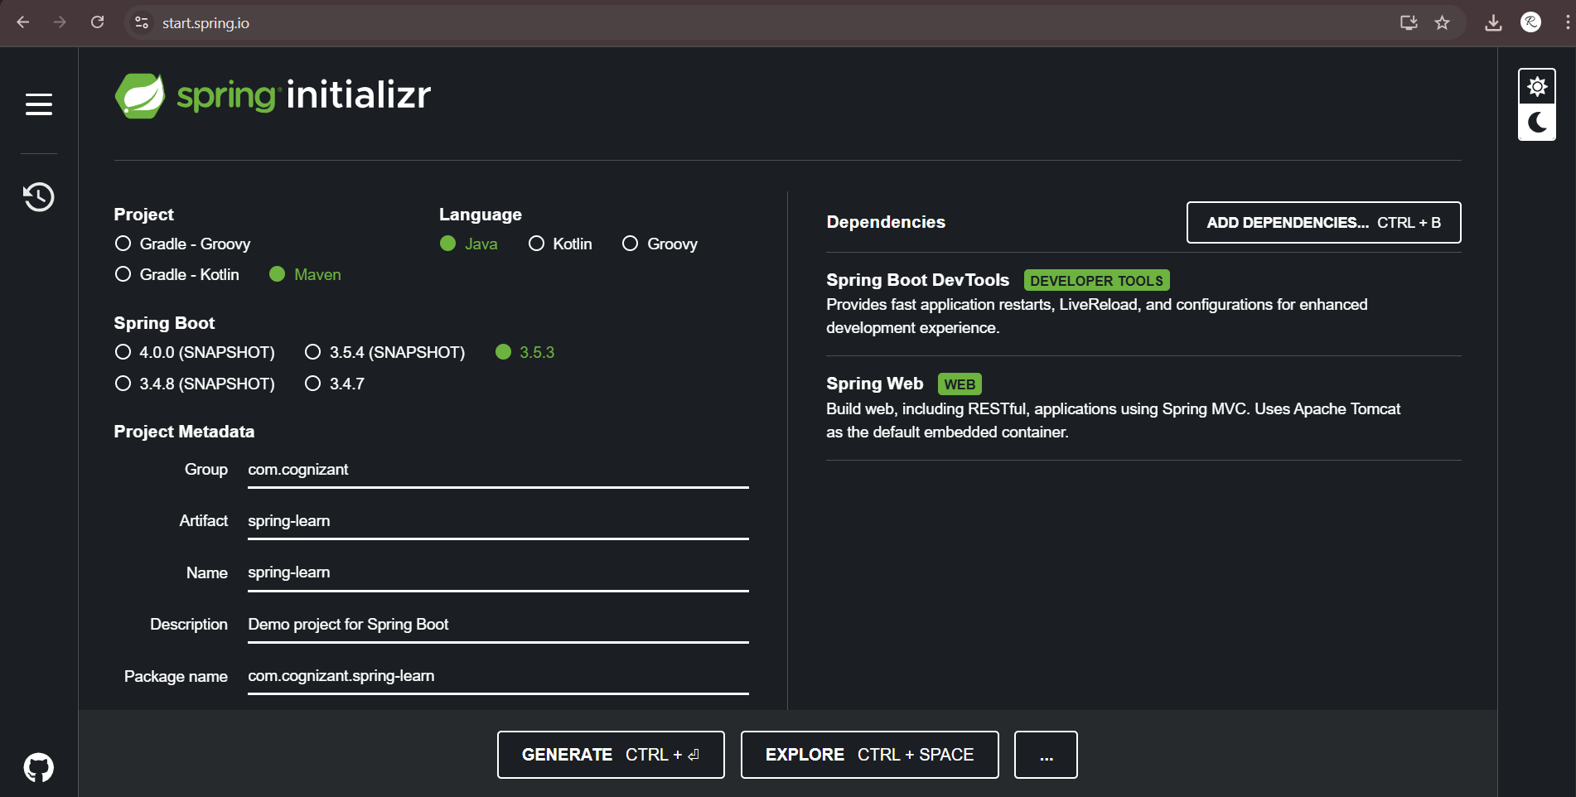

**SpringLearnApplication.java**

package com.cognizant.springlearn;

import org.slf4j.Logger;

import org.slf4j.LoggerFactory;

import org.springframework.boot.SpringApplication;

import org.springframework.boot.autoconfigure.SpringBootApplication;

*@SpringBootApplication*

public class SpringLearnApplication {

private static final Logger ***LOGGER*** = LoggerFactory.*getLogger*(SpringLearnApplication.class);

public static void main(String[] args) {

SpringApplication.*run*(SpringLearnApplication.class, args);

***LOGGER***.info("Inside main");

}

}

**Output:**

